

| Course Number | COE328 |
| --- | --- |
| Course Title | Digital Systems - F2022 |
| Semester/Year | Fall 2022 |
| Instructor | Shazzat Hossain |
| TA Name | Sajjad |

| Lab/Tutorial Report No. | Lab 1 Part 2 |
| --- | --- |

| Report Title | **Introduction to CAD tools** |
| --- | --- |

| Section No. | 11 |
| --- | --- |
| Group No. | N/A |
| Submission Date | Sept 23, 2022 |
| Due Date | Sept 25, 2022 |

| Student Name | Student ID | Signature* |
| --- | --- | --- |
| [Hamza Malik](mailto:hamza.ejaz.malik@ryerson.ca) | 501112545 |  |

*\*By signing above you attest that you have contributed to this submission and confirm that all work you have contributed to this submission is your own work. Any suspicion of copying or plagiarism in this work will result in an investigation of Academic Misconduct and may result in a “0” on the work, an “F” in the course, or possibly more severe penalties, as well as a Disciplinary Notice on your academic record under the Student Code of Academic Conduct, which can be found online at:*

[*http://www.ryerson.ca/content/dam/senate/policies/pol60.pdf*](http://www.ryerson.ca/content/dam/senate/policies/pol60.pdf)

**Skeleton code:**

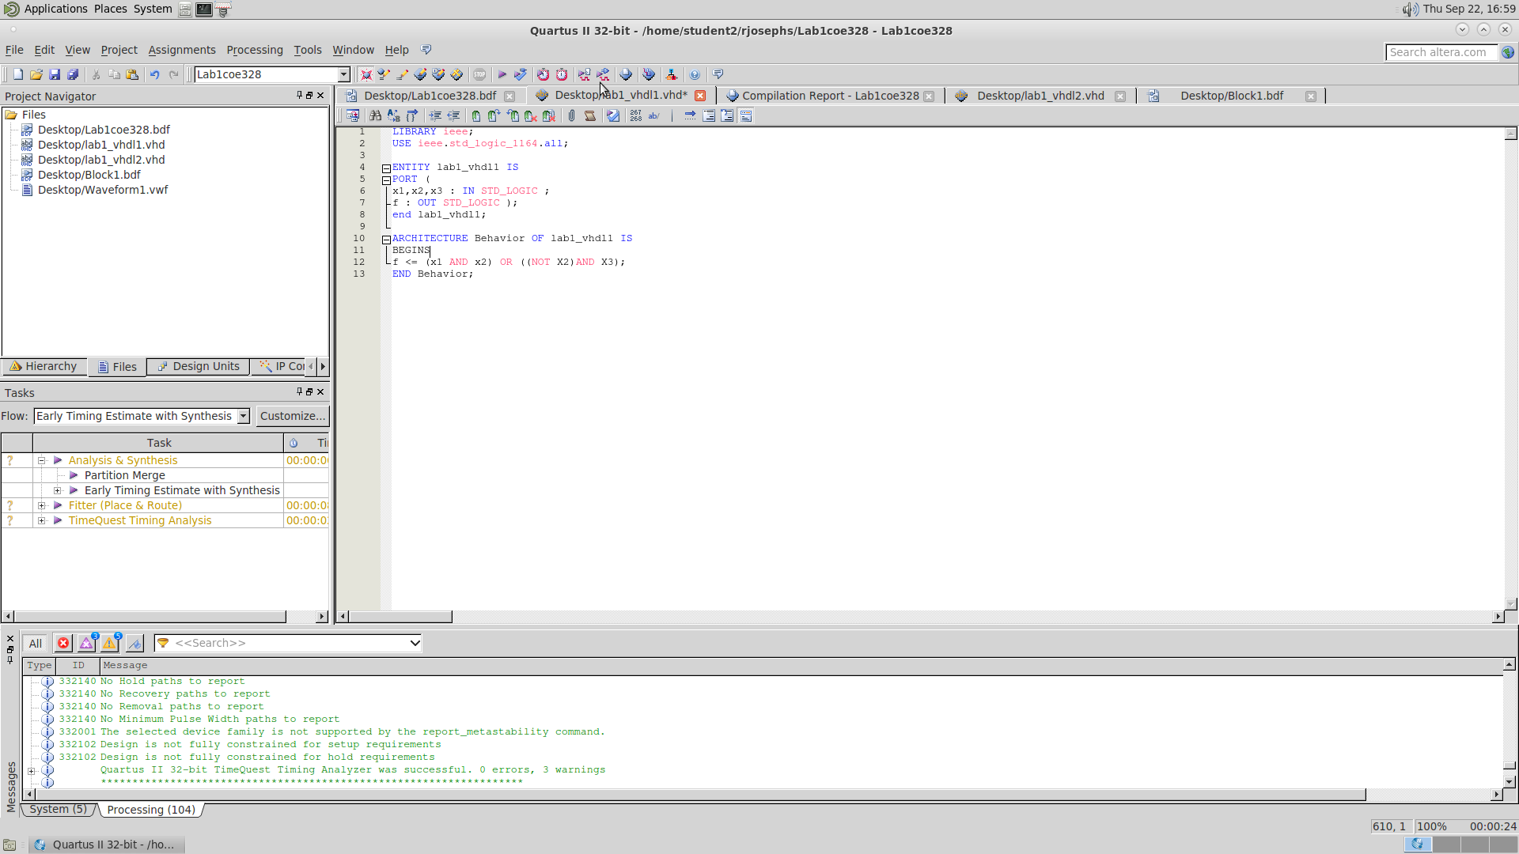

- This, is Skeleton code for lab1_vhdl1.vhd created on week two of our lab 1

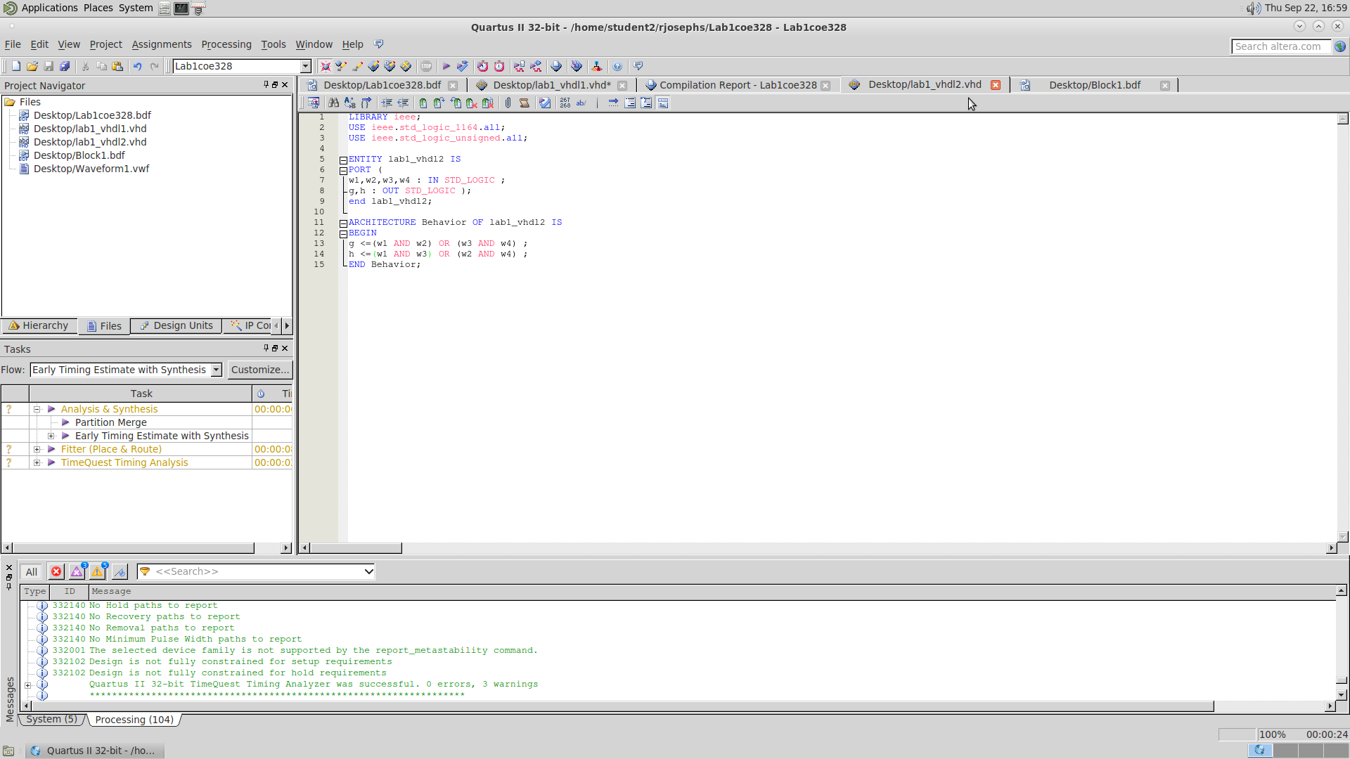

- This is Skeleton code for lab1_vhdl2.vhd created on week two of our lab 1

**Schematic Design/Block Diagram:**

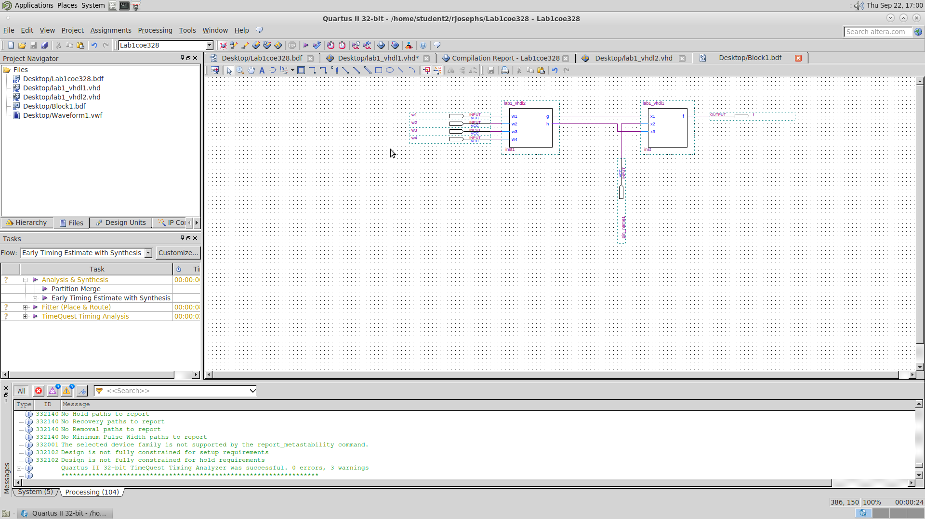

- This is a picture of our block diagram schematics of mixed design created on week two of our lab 1 using Quartus II 13.0 made with lab1_vhdl1.bsf symbol and lab1_vhdl2.bsf symbol.

**Waveform Simulation Diagram:**

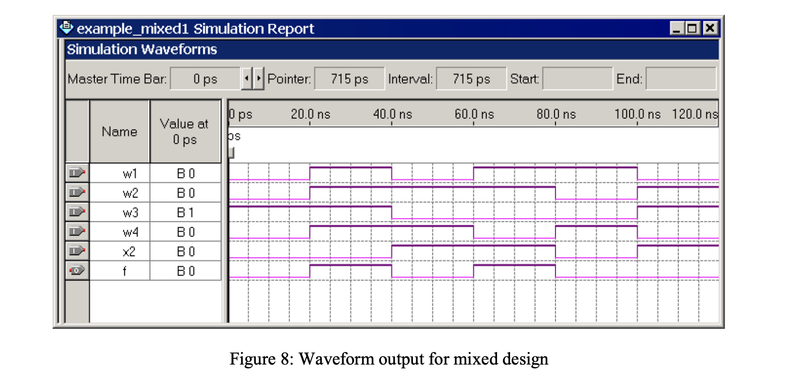

- For Waveform created in week 2 for lab 1, the computer software for Quartus II 13.0 was having issues in outputting waveforms which is why a picture of it couldn’t be included, and our TA Sajjad is aware of it.

**Conclusion:**

To wrap up our lab 1 part two, we observed another method of creating a logical circuit design through writing VHDL code. In this method, 2 Skeleton codes were created and compiled to verify their basic logical functionalities and then, with further steps, were created into symbols for both Skeleton codes. Those symbols were imported to the block diagram schematics file and created into the mixed design. In the mixed design, there were five input pins, 4 of which were connected through VHDL symbol 2 and 1 connected through VHDL symbol 1, which gave us output f. We then compiled the design and created a waveform vector file to perform wave simulations on the design. We then introduced values for the input ports and created the waveform design. Once the waveform designs were created according to the lab outline figure 8, we compiled the waveform, giving us a waveform output f for the mixed design.